***ENGAGEMENT NAME:*** *FORD FINAPP SHOP AND BUY*

***TECH ANCHOR:*** *ASH ALAM*

***TIME:*** *June 2021 - till date*

***CONTRIBUTIONS TO THE PROJECT (In detail):***

***Major*** *features lead over* ***8 PI*** *releases –*

*1. Cypress Automation (highlight of the year) –*

*To improve the pace of value to customers, it was proposed that all externalized testing currently performed at a program level for FinApp (aka E2E testing) is internalized into the team. This allowed features to be developed and tested and released truly incrementally, reducing cycle times from* ***6 weeks to at most 1.5 hours****, thus receiving faster feedback. This also reduced dependencies on external teams and allowed releasing on demand and more accurate forecasting and planning.*

*As part of this feature, I have developed an automation test suite for* ***four European countries*** *– the UK, Italy, Spain, and France.*

*2. DE lease journey –*

*Accommodated and released a new lease journey for the German market in FinApp.*

*3. SonarQube Remediations*

*4. First adjusted instalment*

***Partially*** *lead the following features –*

*1. IT OTP – Initial refinement and discovery*

*2. Content authoring (Strapi) for GB market – Post refinement implementation and QA*

*3. FE/BE Code split up (ongoing)*

***Continuous*** *development of other features (not limited to) –*

*1. Cleanup and refactor the codebase*

*2. Business features to improvise customer journey*

***Other contributions*** *–*

*1. Adopted fair discipline practices in the team – led retrospection calls, created strategy document for branching techniques and suggested ideas for improvising sprint commitments.*

*2. Mentoring Analysts to upgrade relevant skills*

***SUMMARY:*** *The range of responsibilities undertaken during the tenure of developing the FinApp includes - backlog management, process definition, development and QA, and support and delivery management.*

***STANDARD GOALS:***

1. ***Project Delivery*** 
   1. ***Delivery*** 
      1. *Focus on writing scalable and maintainable code*
      2. *Handle features independently*
      3. *Became more confident about Test Driven Development patterns. I committed to my professional growth and have taken training courses (React Testing Library and Cypress automation) specific to the skills required for my current assignment/project*
      4. *I feel confident collaborating with my teammates and often provide guidance and training on the subject areas I am skilled.*
      5. *Expanded project management knowledge and proposed solutions for improving team productivity*
      6. *Update and maintain tech designs*
      7. *Present and deliver the work done independently.*
   2. ***Project timeline***
      1. *Improved feature development estimates by understanding the requirements of clients and adopting new ways of working with team members*
      2. *I communicate my expectations and progress to the team and never over-commit to something that I can’t do or follow. I make sure that none of my team members is blocked in their tasks*
      3. *I plan my workdays, leaves and workload, which helps me effectively commit to my sprint goals.*
   3. ***Client management***
      1. *Frequently communicate with the clients to help them understand the technical challenges/concerns for certain features.*
2. ***Creating an Impact –*** *Received appreciation for the work and presentations*

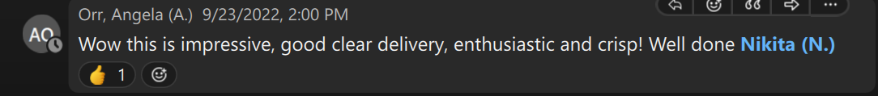

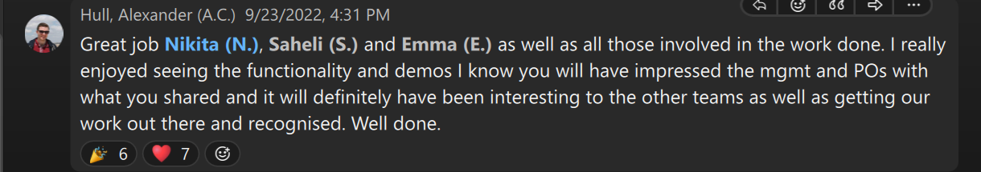

***STRETCH GOALS:***

1. ***Mentoring***
   1. *Provided guidance to Analysts and fellow consultants for navigating through project codebase*
   2. *Helped Analysts and fellow consultants expand their technical skillset and trained them for project-specific skill sets.*
2. ***Contribution to Sales/Support clients/Firm***
   1. *Proactively developed and maintained relationships at middle management with the current client and teams in UK and USA*
   2. *Volunteered for firm initiatives (CSR activities)*
      1. *Created learning material (English Grammar) for secondary school students*
      2. *Visited NGO to teach arts and crafts to spec children on Impact day in Navi Mumbai city*

***DEVELOPMENT GOALS***

*Completed training for –*

*1. Google Cloud Practitioner – Also appeared and cleared GCP foundational exam.*

*2. Micro frontends*

*Ongoing training – Strapi CMS*

*Upcoming trainings - Module Bundler (Webpack or Rollup.js)*